**Acropolis Institute Of Technology And Research,**

**Indore (M.P.)**



**Subject – Database Management System (DBMS)**

**(CY-405)**

**Name – BHARTI MALVIYA**

**Enrollment No. - 0827CY221020**

**Branch - CS(Cyber Security)**

**Semester - 4th  (2nd year)**

**Submitted To – Mrs. Nidhi Nigam Ma’am**

**Index**

|  |  |  |  |  |
| --- | --- | --- | --- | --- |
| **Sr. No.** | **Experiment** | **Date of Exp.** | **Date of sub.** | **Grade** |
| 1. | To study DBMS and RDBMS, its characteristic comparisons and study of popular DB software. | 11/03/24 | 18/03/24 |  |
|  |  |  |  |  |
|  |  |  |  |  |
|  |  |  |  |  |
|  |  |  |  |  |
|  |  |  |  |  |
|  |  |  |  |  |
|  |  |  |  |  |
|  |  |  |  |  |
|  |  |  |  |  |
|  |  |  |  |  |
|  |  |  |  |  |

**LAB WORK 1**

Introduction to DBMS :-

Database Management Systems (DBMS) are software systems used to store, retrieve, and run queries on data. A DBMS serves as an interface between an end-user and a database, allowing users to create, read, update, and delete data in the database.

DBMS manage the data, the database engine, and the database schema, allowing for data to be manipulated or extracted by users and other programs. This helps provide data security, data integrity, concurrency, and uniform data administration procedures.

DBMS optimizes the organization of data by following a database schema design technique called normalization, which splits a large table into smaller tables when any of its attributes have redundancy in values. DBMS offer many benefits over traditional file systems, including flexibility and a more complex backup system.

Database management systems can be classified based on a variety of criteria such as the data model, the database distribution, or user numbers. The most widely used types of DBMS software are relational, distributed, hierarchical, object-oriented, and network.

Types of DBMS :-

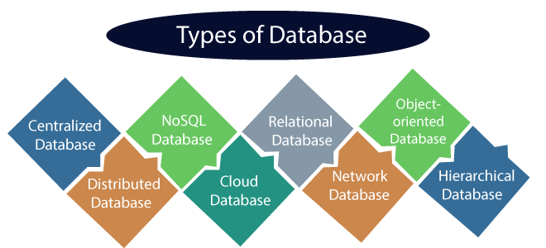

1) Centralized Database

It is the type of database that stores data at a centralized database system. It comforts the users to access the stored data from different locations through several applications. These applications contain the authentication process to let users access data securely. An example of a Centralized database can be Central Library that carries a central database of each library in a college/university.

## 2) Distributed Database

Unlike a centralized database system, in distributed systems, data is distributed among different database systems of an organization. These database systems are connected via communication links. Such links help the end-users to access the data easily. **Examples** of the Distributed database are Apache Cassandra, HBase, Ignite, etc.

We can further divide a distributed database system into:

* **Homogeneous DDB:** Those database systems which execute on the same operating system and use the same application process and carry the same hardware devices.
* **Heterogeneous DDB:** Those database systems which execute on different operating systems under different application procedures, and carries different hardware devices.

## 3) Relational Database

This database is based on the relational data model, which stores data in the form of rows(tuple) and columns(attributes), and together forms a table(relation). A relational database uses SQL for storing, manipulating, as well as maintaining the data. E.F. Codd invented the database in 1970. Each table in the database carries a key that makes the data unique from others. **Examples** of Relational databases are MySQL, Microsoft SQL Server, Oracle, etc.

## 4) NoSQL Database

Non-SQL/Not Only SQL is a type of database that is used for storing a wide range of data sets. It is not a relational database as it stores data not only in tabular form but in several different ways. It came into existence when the demand for building modern applications increased. Thus, NoSQL presented a wide variety of database technologies in response to the demands. We can further divide a NoSQL database into the following four types:

5) Cloud Database

A type of database where data is stored in a virtual environment and executes over the cloud computing platform. It provides users with various cloud computing services (SaaS, PaaS, IaaS, etc.) for accessing the database. There are numerous cloud platforms, but the best options are:

* Amazon Web Services(AWS)
* Microsoft Azure
* Kamatera
* PhonixNAP
* ScienceSoft
* Google Cloud SQL, etc.

6) Object-oriented Databases

The type of database that uses the object-based data model approach for storing data in the database system. The data is represented and stored as objects which are similar to the objects used in the object-oriented programming language.

7) Hierarchical Databases

It is the type of database that stores data in the form of parent-children relationship nodes. Here, it organizes data in a tree-like structure.

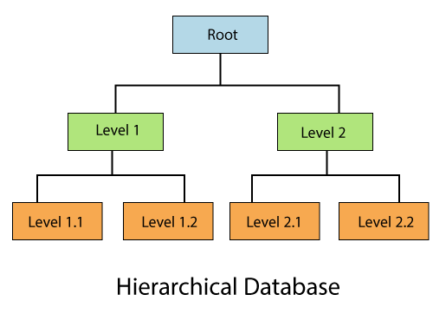 Data get stored in the form of records that are connected via links. Each child record in the tree will contain only one parent. On the other hand, each parent record can have multiple child records.

## 9) Personal Database

Collecting and storing data on the user's system defines a Personal Database. This database is basically designed for a single user.

## 10) Operational Database

The type of database which creates and updates the database in real-time. It is basically designed for executing and handling the daily data operations in several businesses. For example, An organization uses operational databases for managing per day transactions.

## 11) Enterprise Database

Large organizations or enterprises use this database for managing a massive amount of data. It helps organizations to increase and improve their efficiency. Such a database allows simultaneous access to users.

KEY FEATURES OF DBMS :-

1. Data Security

Features of ER Model in DBMS - Data security is paramount in an era where data breaches and cyberattacks are rampant. DBMS provides robust mechanisms for securing sensitive information. Access control, authentication, and encryption are tools at its disposal. With DBMS, administrators can define who can access specific data, what actions they can perform, and when they can do it. This feature ensures that only authorised personnel can access and modify critical data.

2. Data Integrity

Data integrity ensures that data remains accurate and consistent throughout its lifecycle. DBMS enforces data integrity constraints, such as primary keys, foreign keys, and check constraints, preventing erroneous or inconsistent data insertion. This feature helps maintain data accuracy and reliability, which is vital for decision-making.

3. Data Recovery

Data loss can be catastrophic for businesses. DBMS offers additional features of the ER model in DBMS data recovery features, including backups and transaction logs. Backups allow organisations to restore data to a previous state in case of hardware failure or data corruption. Transaction logs record all changes to the database, enabling point-in-time recovery. These features of DBMS ensure data continuity and minimise downtime.

4. Concurrency Control

In multi-user environments, simultaneous access to the database can lead to conflicts and inconsistencies. DBMS employs concurrency control mechanisms to manage concurrent transactions effectively. Techniques like locking and timestamp-based protocols ensure that multiple users can work on the same data without interfering with each other.

5. Query Language

Features of SQL in DBMS - Users need a way to communicate their requests to interact with a database. DBMS provides a standardised query language, such as SQL (Structured Query Language), which allows users to retrieve, update, and manipulate data in a database. SQL is a powerful tool that enables complex data operations with ease.

6. Scalability

As organisations grow, their data requirements expand exponentially. DBMS offers scalability features to accommodate this growth. DBMS can adapt to changing data needs, whether horizontal scaling (adding more servers) or vertical scaling (upgrading hardware), ensuring optimal performance.

7. Data Redundancy Control

Data redundancy can lead to inconsistencies and wasted storage space. DBMS minimises redundancy by using normalisation techniques, which organise data in a way that reduces duplication. This not only saves storage space but also enhances data consistency.

8. ACID Properties

The foundation of database transactions is the ACID properties (Atomicity, Consistency, Isolation, and Durability). DBMS ensures that transactions are atomic (indivisible), consistent (follow defined rules), isolated (do not interfere with each other), and durable (persist even after system failures). These properties guarantee data reliability and maintain the integrity of the database.

9. Indexing

Efficient data retrieval is crucial for performance. DBMS uses indexing to create data structures that allow for rapid data access. Indexes provide a roadmap to the data, reducing the time needed to retrieve information. They are essential for speeding up search operations in large databases.

10. Data Compression and Storage Optimization

In a world where data storage costs can skyrocket, features of DBMS for data compression and storage optimisation. This reduces storage expenses and improves query performance by reducing the amount of data that needs to be processed.

11. Data Backup and Recovery

Data is the lifeblood of any organisation, and losing it can be catastrophic. DBMS systems have robust backup and recovery mechanisms to protect data. Regular backups and recovery plans safeguard data against hardware failures, human errors, and cyberattacks.

Application of DBMS:-

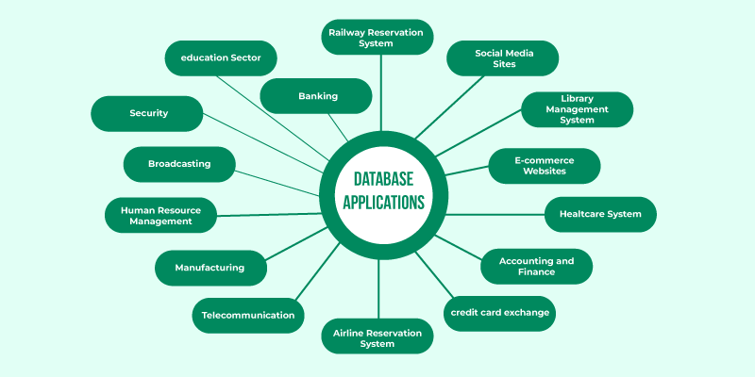

### 1. Railway And Airline Reservation System

The database keeps a record of ticket booking, arrival time, departure time, delays, and even seat numbers of airplanes or trains.

### 2. Library Management System

There can be tens of thousands of books in a library, so it becomes very important to keep a record of the details of each book. Handwritten records can prove to be a real hassle when managing literally thousands of books. DBMS comes into play here, all the details of each book - name, author, number of pages, availability, quantity, etc., can be managed using a Database Management System.

### 3. Banking

An uncountable number of bank transactions and deposits are made, thousands of new bank accounts are created daily, and many such things. This is all possible because of a Database Management System that makes keeping track of the record much easier.

### 4. Education Sector (Schools and Colleges)

The details of each student, teacher, and even janitor are stored in a database to manage the information easily.

### 5. Social Media Sites (Instagram, Facebook, etc.)

Social media websites like Instagram, Facebook, Whatsapp, etc., are able to keep track of each and every detail of their users (name, phone number, photos, email address, password, etc.) with the help of Database Management Systems.

### 6. Online Shopping (E-commerce Platforms Like Amazon)

With time, more and more people have started shopping online, no one wants to go to a shop and waste their time when they can do the same thing while at home and save time. With the increase in online shopping customers, there's a need to store their details efficiently.  
That is why, all the details of the customers, products as well as order and tracking details are stored and managed using a Database Management System.

What Is MySQL

MySQL is the world’s most popular open source database. According to [DB-Engines](https://db-engines.com/en/ranking), MySQL ranks as the second-most-popular database, behind [Oracle Database](https://www.oracle.com/in/database/). MySQL powers many of the most accessed applications, including Facebook, Twitter, Netflix, Uber, Airbnb, Shopify, and Booking.com.

Since MySQL is open source, it includes numerous features developed in close cooperation with users over more than 25 years. So it’s very likely that your favorite application or programming language is supported by MySQL Database.

## MySQL is a relational database management system

[Databases](https://www.oracle.com/in/database/what-is-database/) are the essential data repository for all software applications. For example, whenever someone conducts a web search, logs in to an account, or completes a transaction, a database system is storing the information so it can be accessed in the future.

A [relational database](https://www.oracle.com/in/database/what-is-a-relational-database/) stores data in separate tables rather than putting all the data in one big storeroom. The database structure is organized into physical files optimized for speed. The logical data model, with objects such as data tables, views, rows, and columns, offers a flexible programming environment. You set up rules governing the relationships between different data fields, such as one to one, one to many, unique, required, or optional, and “pointers” between different tables. The database enforces these rules so that with a well-designed database your application never sees data that’s inconsistent, duplicated, orphaned, out of date, or missing.

The “SQL” part of “MySQL” stands for “Structured Query Language.” SQL is the most common standardized language used to access databases. Depending on your programming environment, you might enter SQL directly (for example, to generate reports), embed SQL statements into code written in another language, or use a language-specific API that hides the SQL syntax.

## MySQL is open source

[Open source](https://developer.oracle.com/open-source/what-is-open-source/) means it’s possible for anyone to use and modify the software. Anybody can download MySQL software from the internet and use it without paying for it. You can also change its source code to suit your needs. MySQL software uses the [GNU General Public License](http://www.fsf.org/licenses/) (GPL) to define what you may and may not do with the software in different situations.

If you feel uncomfortable with the GNU GPL or need to embed MySQL code into a commercial application, you can buy a commercially licensed version from Oracle. See the [MySQL Licensing Information section](https://www.mysql.com/about/legal/) for more information.

MySQL Benefits

MySQL is fast, reliable, scalable, and easy to use. It was originally developed to handle large databases quickly and has been used in highly demanding production environments for many years.

Although MySQL is under constant development, it offers a rich and useful set of functions. MySQL’s connectivity, speed, and security make it highly suited for accessing databases on the internet.

MySQL’s key benefits include

**Ease of use:** Developers can install MySQL in minutes, and the database is easy to manage.

**Reliability:** MySQL is one of the most mature and widely used databases. It has been tested in a wide variety of scenarios for more than 25 years, including by many of the world’s largest companies. Organizations depend on MySQL to run business-critical applications because of its reliability.

**Scalability:**MySQL scales to meet the demands of the most accessed applications. MySQL’s native replication architecture enables organizations such as Facebook to scale applications to support billions of users.

**Performance:** MySQL HeatWave is faster and less expensive as demonstrated by multiple standard industry benchmarks, including TPC-H, TPC-DS, and CH-benCHmark

**High availability:** MySQL delivers a complete set of native, fully integrated replication technologies for high availability and disaster recovery. For business-critical applications, and to meet service-level agreement commitments, customers can achieve

* Recovery point objective = 0 (zero data loss)
* Recovery time objective = seconds (automatic failover)

**Security:** [Data security](https://www.oracle.com/in/security/database-security/what-is-data-security/) entails protection and compliance with industry and government regulations, including the European Union General Data Protection Regulation, the Payment Card Industry Data Security Standard, the Health Insurance Portability and Accountability Act, and the Defense Information Systems Agency’s Security Technical Implementation Guides. MySQL Enterprise Edition provides advanced security features, including authentication/authorization, transparent data encryption, auditing, data masking, and a database firewall.

**Flexibility:**The MySQL Document Store gives users maximum flexibility in developing traditional SQL and NoSQL schema-free database applications. Developers can mix and match relational data and JSON documents in the same database and application.

## MySQL use cases

**Cloud applications:** MySQL is very popular in the cloud. [MySQL HeatWave](https://www.oracle.com/in/mysql/) is a fully managed database service, powered by the integrated HeatWave in-memory query accelerator. It’s the only cloud database service that combines transactions, real-time analytics across data warehouses and data lakes, and machine learning (ML) services into one MySQL Database—without the complexity, latency, cost, and risk of ETL duplication. With MySQL HeatWave AutoML, developers and data analysts can build, train, deploy, and explain [machine learning](https://www.oracle.com/in/data-science/machine-learning/what-is-machine-learning/) models within MySQL HeatWave in a fully automated way.

MySQL is extremely popular for

**Ecommerce:**Many of the world’s largest ecommerce applications (for example, Shopify, Uber, and Booking.com) run their transactional systems on MySQL. It’s a popular choice for managing user profiles, credentials, user content, financial data including payments, and fraud detection.

**Social platforms:** Facebook, Twitter, and LinkedIn are among the world’s largest social networks that rely on MySQL.

**Content management:**Unlike single-purpose document databases, MySQL enables both SQL and NoSQL with a single database. The MySQL Document Store enables CRUD operations and the power of SQL to query data from JSON documents for reporting and analytics.

**SaaS and ISVs:** More than 2,000 ISVs, OEMs, and VARs, including Ericsson, F5, and IBM, rely on MySQL as their embedded database to make their applications, hardware, and appliances more competitive, bring them to market faster, and lower their cost of goods sold. MySQL is also the database behind popular SaaS applications, including Zendesk and HubSpot.

Other popular applications using MySQL include ones for online gaming, digital marketing, retail point-of-sale systems, and Internet of Things monitoring systems.

**On-premises applications with MySQL Enterprise Edition:** MySQL Enterprise Edition includes the most comprehensive set of advanced features, management tools, and technical support to achieve the highest levels of MySQL scalability, security, reliability, and uptime. It reduces the risk, cost, and complexity in developing, deploying, and managing business-critical MySQL applications. It provides security features, including MySQL Enterprise Backup, Monitor, Firewall, Audit, Transparent Data Encryption, and Authentication, to help customers protect data and achieve regulatory and industry compliance.

|  |  |
| --- | --- |
| **DBMS** | **RDBMS** |
| Data is stored in a database management system (DBMS) as a file | Tables are used to store information |
| Data is stored in a database management system (DBMS) in either a navigational or hierarchical format | RDBMS employs a tabular format, with column names as headers and associated data as rows |
| Only a single user is supported by the DBMS | It may be used by numerous people |
| The data in a typical database may not be stored according to the ACID model  This can lead to database discrepancies | Relational databases are more difficult to create, but they are more consistent and organised  They follow the rules of ACID (Atomicity, Consistency, Isolation, Durability) |
| It is an application that is used to manage databases over computer networks as well as the system hard drives | The database systems are used to keep track of the relationships between the tables |
| Software and hardware requirements are minimal | Higher hardware and software requirements are required |
| The integrity constraints are not supported by DBMS  At the file level, the integrity constraints are not imposed | At the schema level, RDBMS provides integrity restrictions  Values outside of a certain range cannot be stored in the RDBMS column |
| Normalization is not supported by DBMS. | A relational database management system (RDBMS) can be normalised. |
| Distributed databases are not supported by DBMS | Distributed databases are supported by RBMS |
| The DBMS system is mostly used to manage tiny amounts of data | The RDBMS database is built to manage a vast volume of data |
| Dbms only meet seven of Dr E.F. Codd’s rules | Dbms meet 8 to 10 of Dr E.F. Codd’s rules |
| Client-server architecture is not supported by DBMS | Client-server architecture is supported by RDBMS |
| For complicated and vast amounts of data, data retrieval takes longer | Because of its relational methodology, data retrieval is quick |
| In this architecture, data redundancy is common | Data redundancy is not possible using keys and indexes |
| There is no correlation between the data | Data is kept in the form of tables that are linked together via foreign keys |
| There is no sense of safety | Multiple security levels are available. At the OS, command, and object levels, log files are produced |
| Individual data items must be accessed | SQL queries make it simple to retrieve data  At the same time, many data items can be accessed |
| A file system, XML, the Windows Registry, and other DBMS are examples | MySQL, Oracle, SQL Server, and other RDBMS are examples |